Network Routing Static, RIP and Wireless

1. Network Topology Overview
- Router0 (R1)
- IP: 192.168.2.1
- Connected to Switch0 via 192.168.1.1
- PCs: 192.168.1.2 (PC0), 192.168.1.3 (PC1)
- Router1 (R2)
- IP: 192.168.2.2
- Connected to Switch1 via 192.168.3.1
- PCs: 192.168.3.2 (PC2), 192.168.3.3 (PC3)

2. Static Routing Configuration Steps

On Router0 (R1):
Router> enable
Router# configure terminal
Router(config)# ip route 192.168.3.0 255.255.255.0 192.168.2.2
Router(config)# exit

On Router1 (R2):
Router> enable
Router# configure terminal
Router(config)# ip route 192.168.1.0 255.255.255.0 192.168.2.1
Router(config)# exit
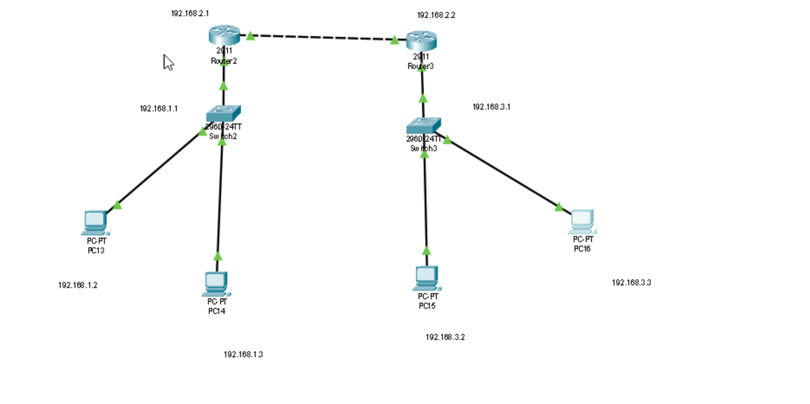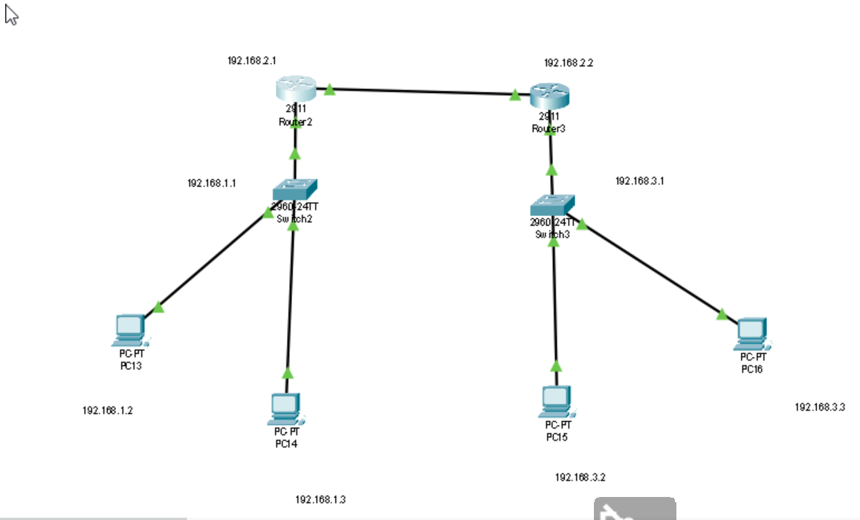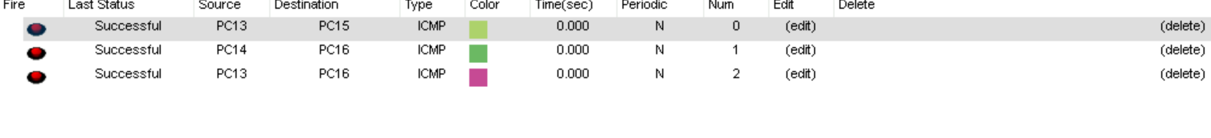

3. RIP Routing Configuration Steps

On Both Routers (R1 and R2):
Router> enable
Router# configure terminal
Router(config)# router rip
Router(config-router)# version 2
Router(config-router)# no auto-summary
Router(config-router)# network 192.168.1.0
Router(config-router)# network 192.168.2.0
Router(config-router)# network 192.168.3.0
Router(config-router)# exit
💡 Use 'show ip route' to verify routing tables.
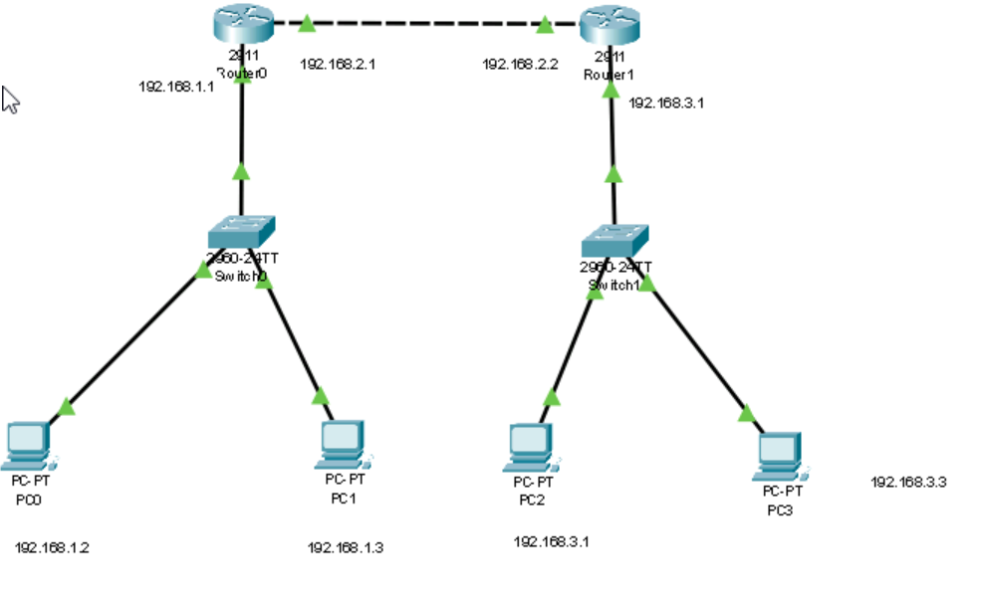

4. Wireless Routing Setup in Cisco Packet Tracer
Objective: Connect wireless devices to a network using a wireless router.

Steps:
1. Add Wireless Router:
- From the device list, drag a Wireless Router (e.g., Linksys) to the workspace.
2. Configure Wireless Router:
- Click on the router → Go to GUI tab.
- Set SSID (e.g., HomeNet).
- Set Security Mode (e.g., WPA2 Personal).
- Set Password (e.g., cisco123).
3. Add Wireless PCs:
- Drag Laptop or PC with wireless capability.
- Click on the PC → Desktop → PC Wireless → Connect to HomeNet.
4. Assign IP Addresses:
- Either use DHCP from the router or assign static IPs manually.
5. Test Connectivity:
- Use ping from one wireless PC to another or to a wired PC to verify routing.
